# Detailed demo instructions User manual for Best Fit Algorithm:

1. Install java and add it’s address to the system environment variable.
2. Download ds-sim.tar and our submission files.
3. Unzip all files and place the file structure as shown below, please put the xml files under the configs folder.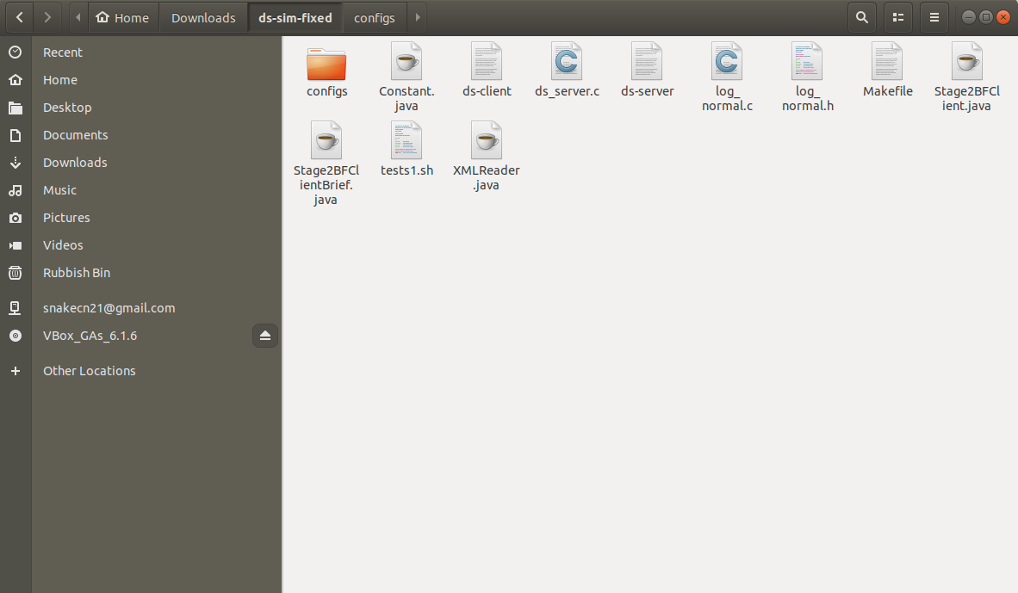
4. You will have two files ds-server and ds-client. To make them executable use the commands below:

# chmod +x ds-server

* 1. **chmod +x ds-client**

1. You may need to change some content in tests1.sh as shown below:

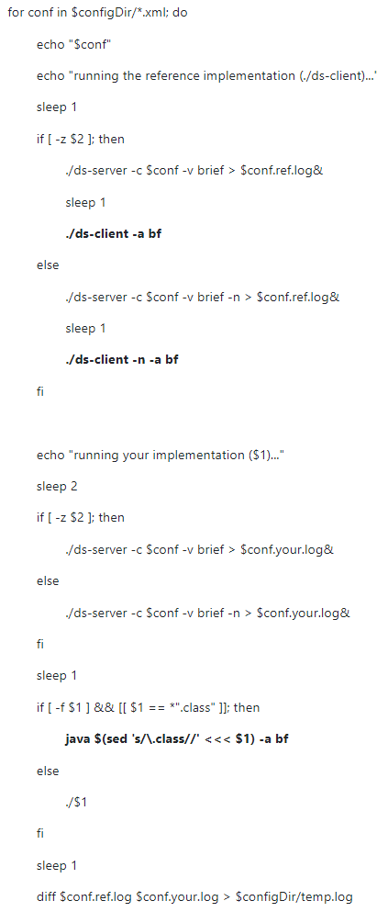

1. You have both server-side and client-side files ready. To run the simulator, open a terminal in the current path.
   1. Compile all java files

# javac Constant.java

# javac XMLReader.java

# javac Stage2BFClientBrief.java

# 

* 1. Run the simulator, and the result as shown below:

# ./tests1.sh Stage2BFClientBrief.class

# 